Setting Up windows Server 2022
Objective: Learning the ins and outs of Windows Server 2022
Project Resources:
Virtual box - https://www.virtualbox.org/wiki/Downloads
Windows server 2022 - https://www.microsoft.com/en-us/evalcenter/download-windows-server-2022

Note all the resources here are free

Step 1: Installation
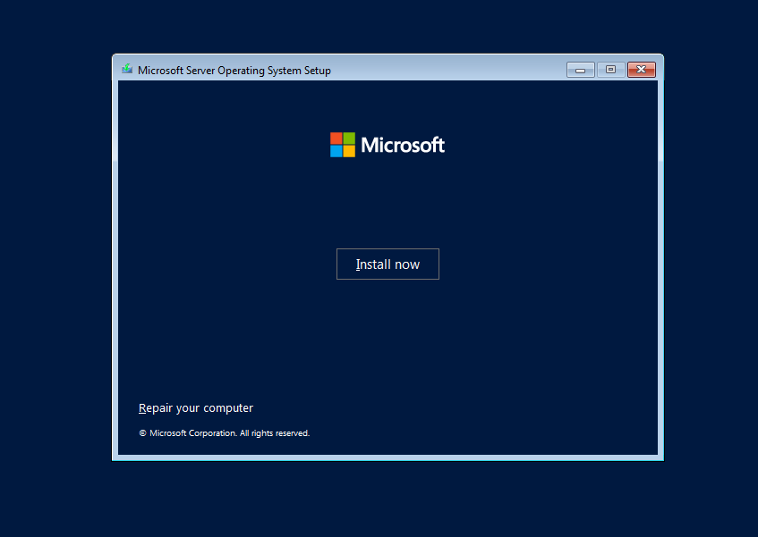

This is usually the first thing you will see when using the windows installer even for non-server versions like windows 10, 11 and their pro versions.

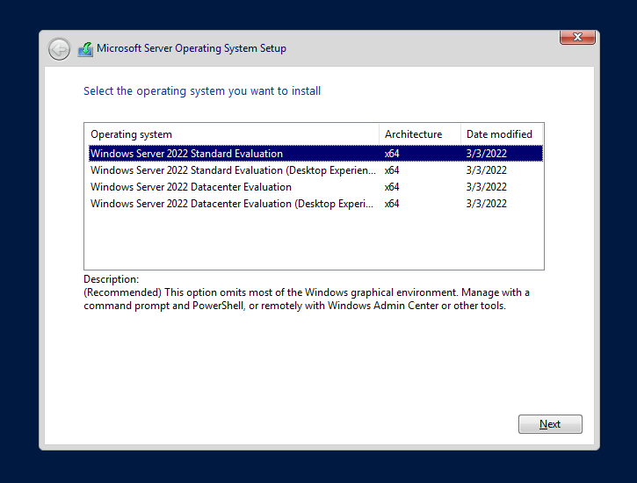

After clicking on the install button you are meet with four options, in our case we will be going with the Standard Evaluation (Desktop Experience). This version we get to use a (Graphical user Interface) GUI environment identical to Windows 10.
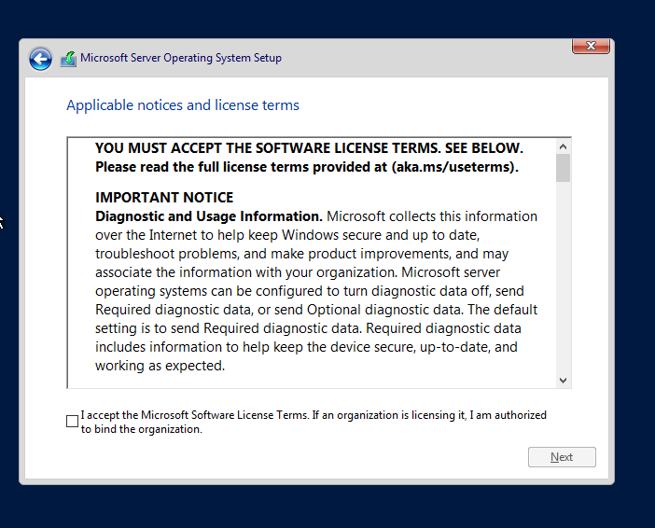
And of course, our beloved terms and conditions which we will obviously accept because we want to use the software.
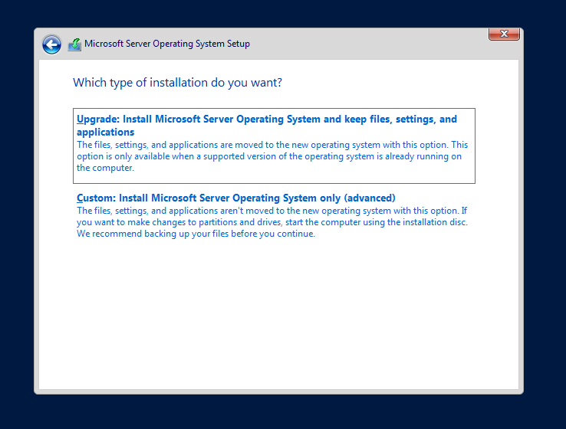

In this guide we will be using the Custom option because this a clean installation, with no prior versions of Windows Server installed.
Okay, after selecting your partition you will see this screen shown below.
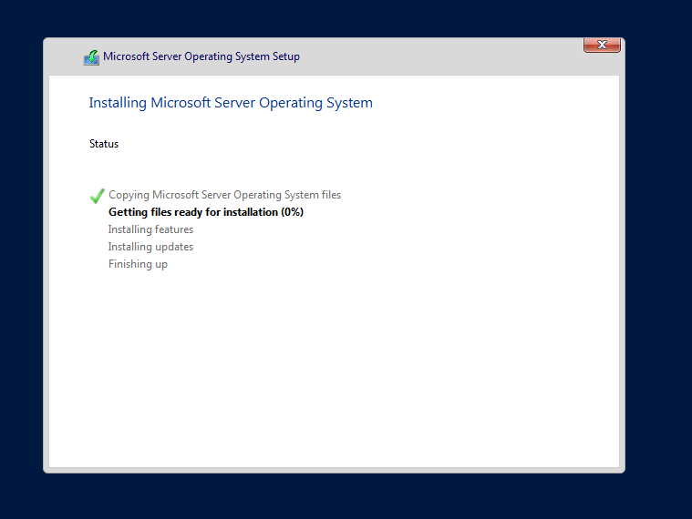

At this point you just wait for the installation to finish. Installation time varies from device to device depending on the hardware specifications.

